PROJECT REPORT



ON

Simple

***Calculator***

SUBMITTED BY :

NAME - LOKESH GUPTA

**TABLE OF CONTENTS**



1. *Introduction*
2. *Proposed system a.Description*

*b.System requirements*

1. *System Design*
2. *Testing*
3. *Future scope of project*

**INTRODUCTION**



**Simple Calculator :**

A fully featured calculator with proper operator

precedence is implemented, including mathematical operatio

ns.

The calculator is written in C program and you are welcome to view the C source. Program does the operations on the given operations which will be user defined.

This program has 7 mathematical operations in total which will

be performed on code.

**PROPOSED SYSTEM**

The following documentation is a project the “Name of the term paper allotted”. It is a detailed summary of all the drawbacks of the old system and how the new proposed system overcomes these shortcomings. The new system takes into account the various factors while designing a new system. It keeps into the account the Economical bandwidth available for the new system. The foremost thing that is taken care of is the Need and Requirements of the User.

**DESCRIPTION**

Before developing software we keep following things in mind that we can develop powerful and quality software

PROBLEM STATEMENT

* Problem statement was to design a module:
* Which is user friendly
* Which will restrict the user from accessing other user’s data.
* Which will help user in viewing his data and privileges.
* Which will help the administrator to handle all the changes.

FUNCTIONS TO BE PROVIDED:

The system will be user friendly and completely menu driven so that the users shall have no problem in using all options.

* The system will be efficient and fast in response.
* The system will be customized according to needs.

**SYSTEM REQUIRMENTS**

Operating system:

Linux or Windows 10



Language: C Language

# SYSTEM DESIGN



Then we began with the design phase of the system. System design is a solution, a “HOW TO” approach to the creation of a new system. It translates system requirements into ways by which they can be made operational. It is a translational from a user oriented document to a document oriented programmers. For that, it provides the understanding and procedural details necessary for the implementation. Here we use Flowchart to supplement the working of the new system. The system thus made should be reliable, durable and above all should have least possible maintenance costs. It should overcome all the drawbacks of the Old existing system and most important of all meet the user requirements.

# APPLICATIONS



In most countries, [students](http://en.wikipedia.org/wiki/Student) use calculators for schoolwork. There was some initial resistance to the idea out of fear that [basic arithmetic skills](http://en.wikipedia.org/wiki/Elementary_arithmetic) would suffer. There remains disagreement about the importance of the ability to perform calculations "in the head", with some curricula restricting calculator use until a certain level of proficiency has been obtained, while others concentrate more on teaching [estimation](http://en.wikipedia.org/wiki/Estimation) techniques and problem-solving. Research suggests that inadequate guidance in the use of calculating tools can restrict the kind of mathematical thinking that students engage in. Others have argued that calculator use can even cause core mathematical skills to atrophy, or that such use can prevent understanding of advanced algebraic concepts.

There are other concerns - for example, that a pupil could use the calculator in the wrong fashion but believe the answer because that was the result given. Teachers try to combat this by encouraging the student to make an estimate of the result manually and ensuring it roughly agrees with the calculated result. Also, it is possible for a child to type in

−1 × −1 and obtain the correct answer '1' without realizing the principle involved. In this sense, the calculator becomes a [crutch](http://en.wikipedia.org/wiki/Crutch) rather than a learning tool, and it can slow down students in exam conditions as they check even the most trivial result on a calculator.

## FUTURE SCOPE OF THE PROJECT



This project will be able to implement in future after making some changes and modifications as we make this project at a very low level.

So the modifications that can be done in our project are:

To make it screen touch so no need to touch key buttons and one more change which can we made is to add snaps of the person who use it.

## TESTING

Testing is the major control measure used during software development. Its basic function is to detect errors in the software. During requirement analysis and design, the output is a document that is usually textual and no executable. After the coding phase, computer programs are available that can be executed for testing purpose. This implies that testing not only, has to uncover errors introduced during coding, but also errors introduced during previous phase. Thus the goal of testing is to uncover the requirements, design and coding errors in the programs. The Source code declared for the program of Simple Calculator has been tested and it has been found that the above source code is okay and correct.

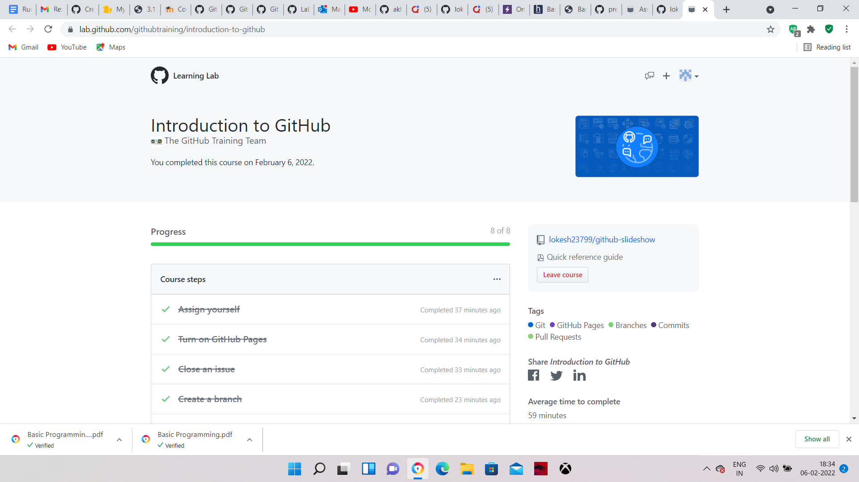

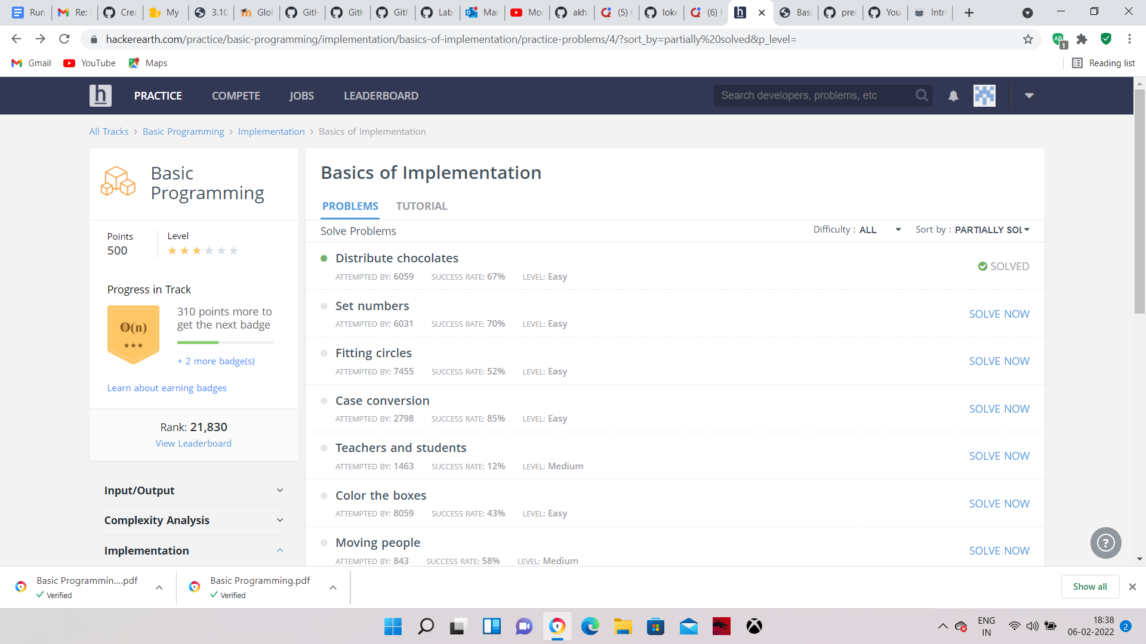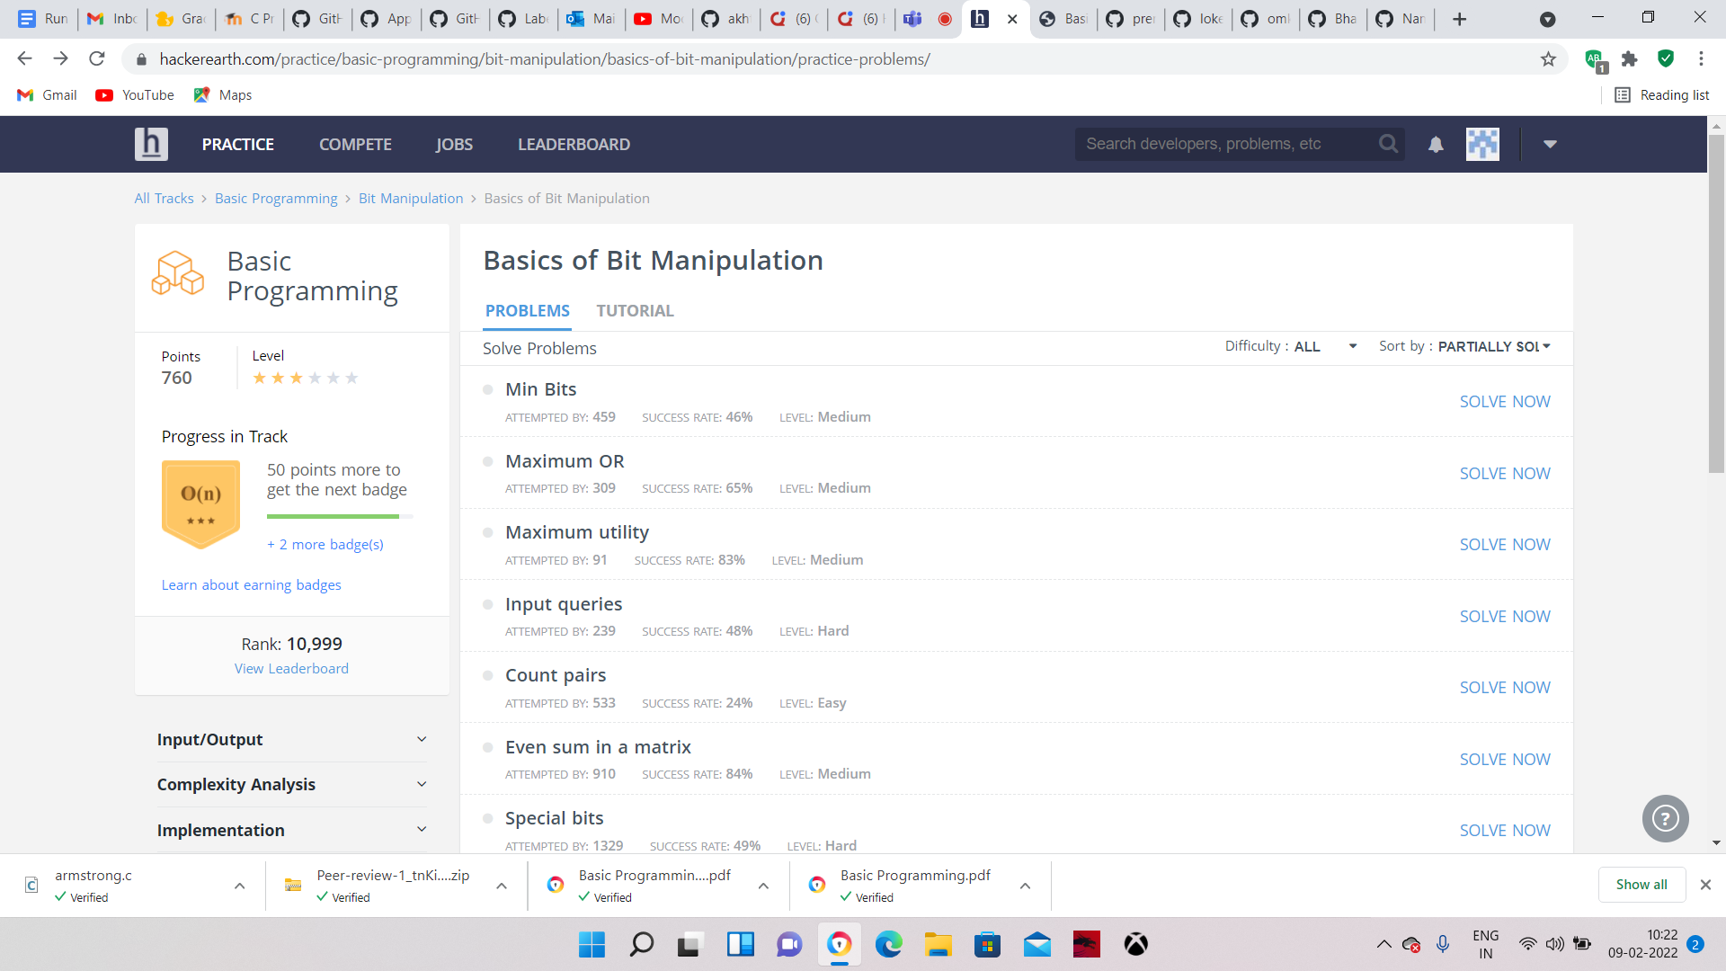

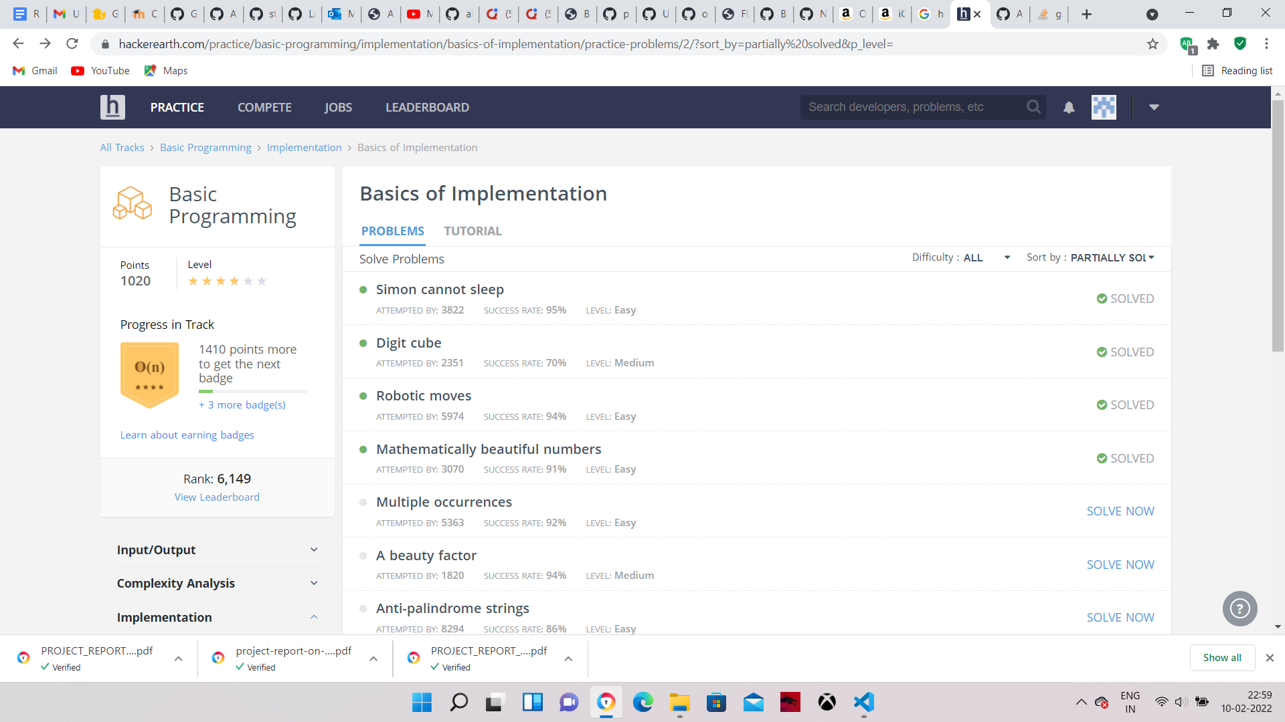

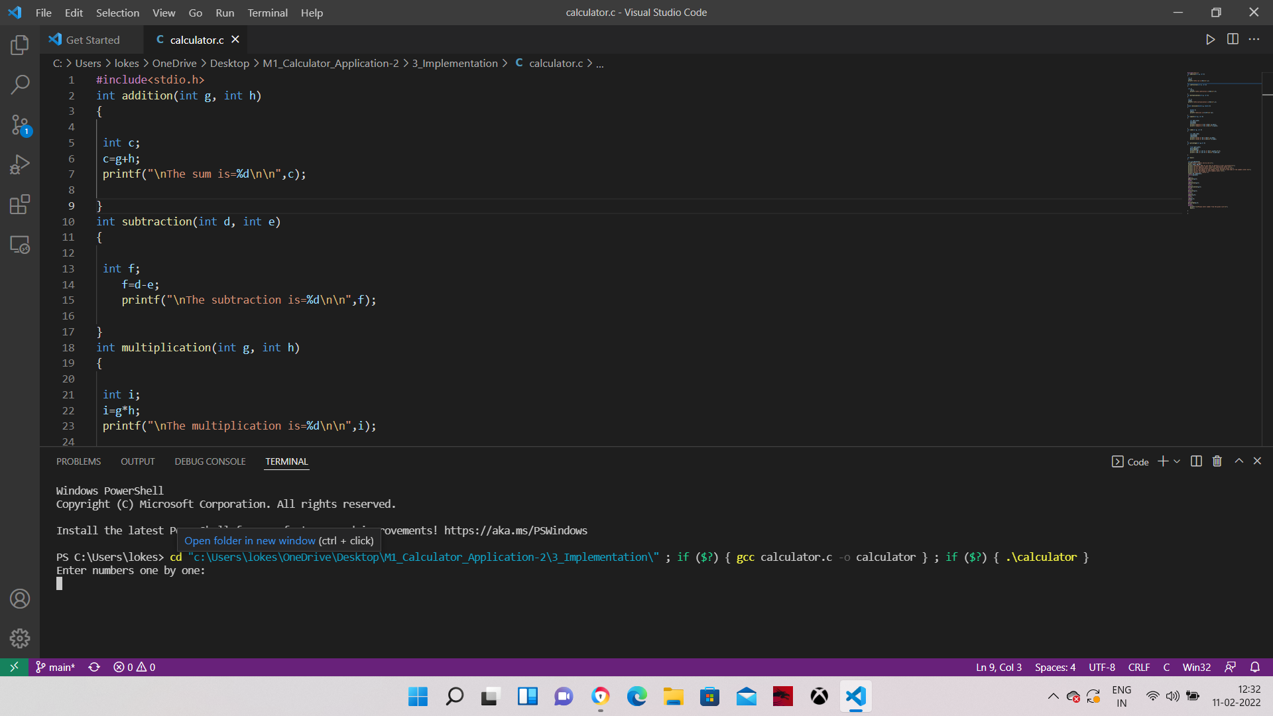

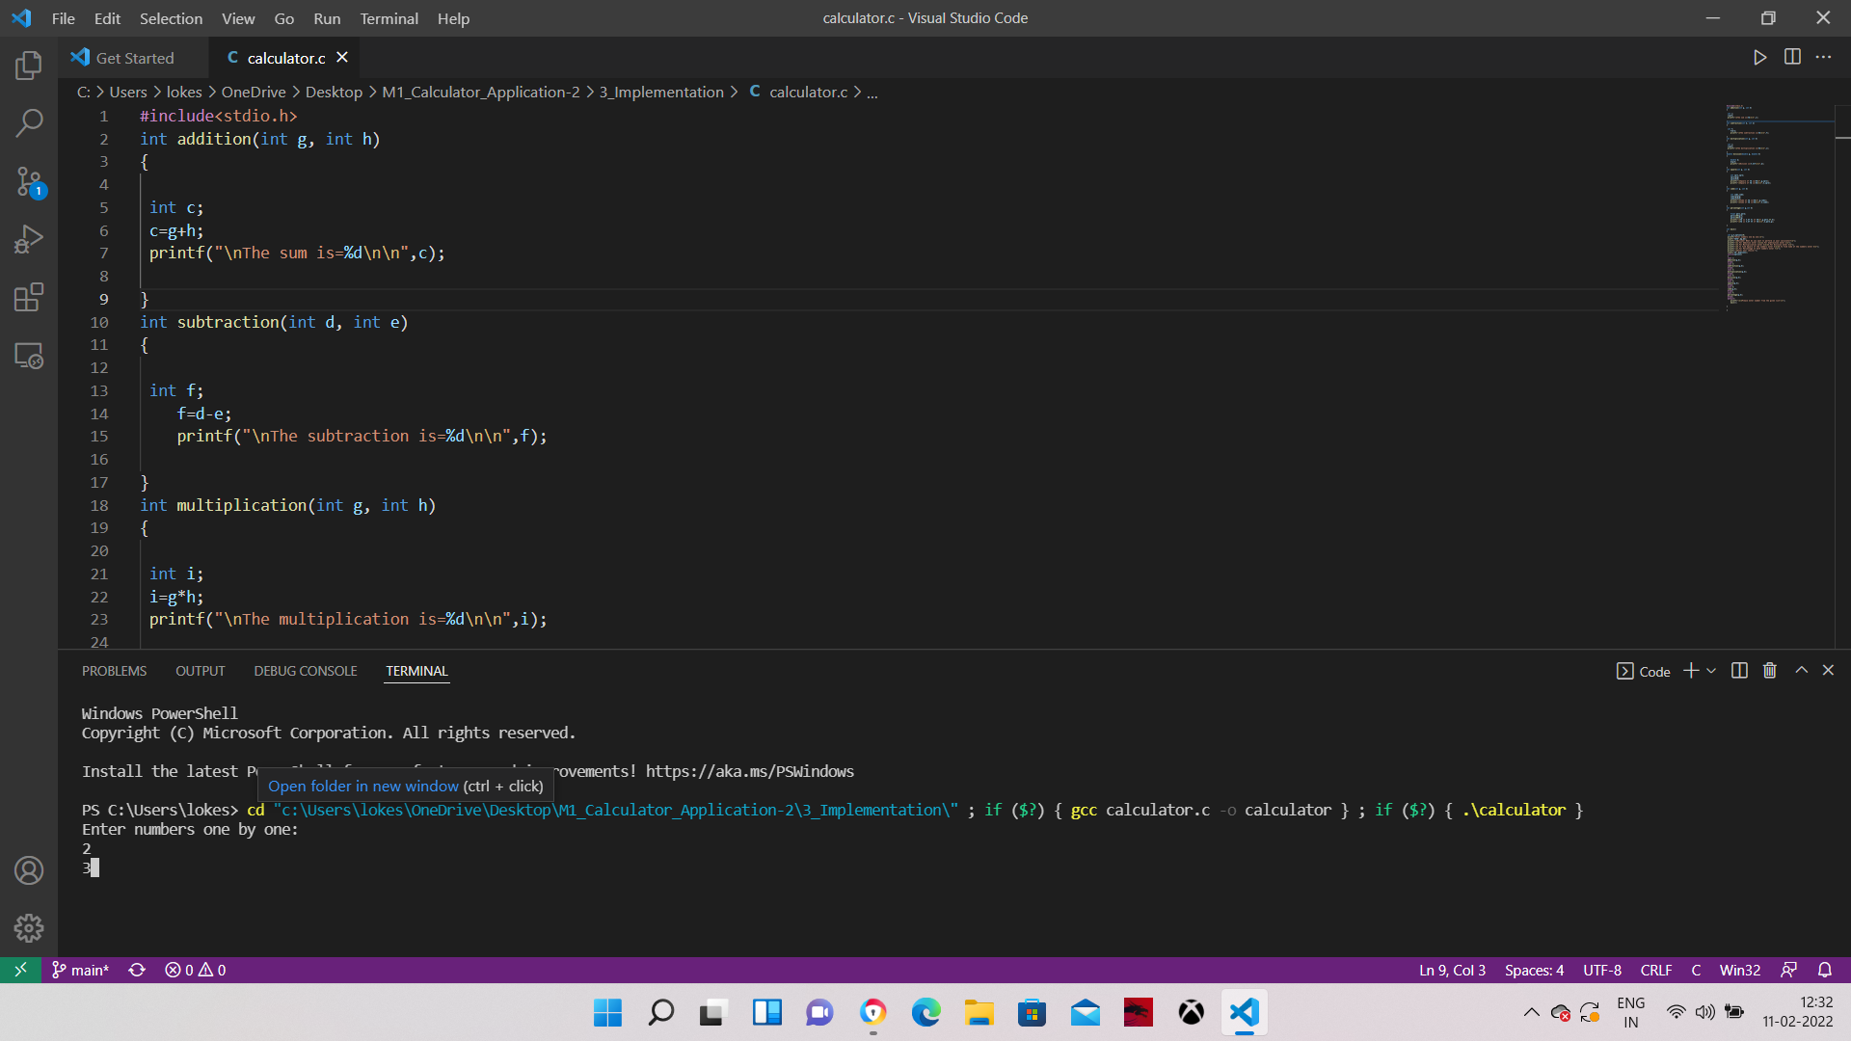

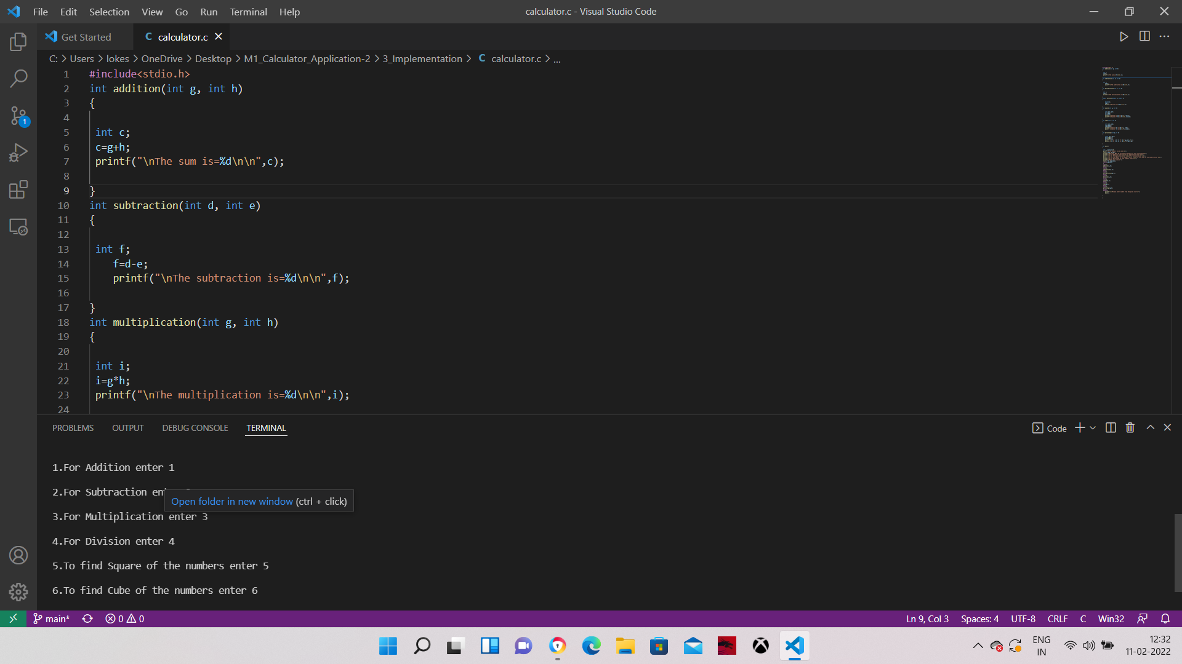

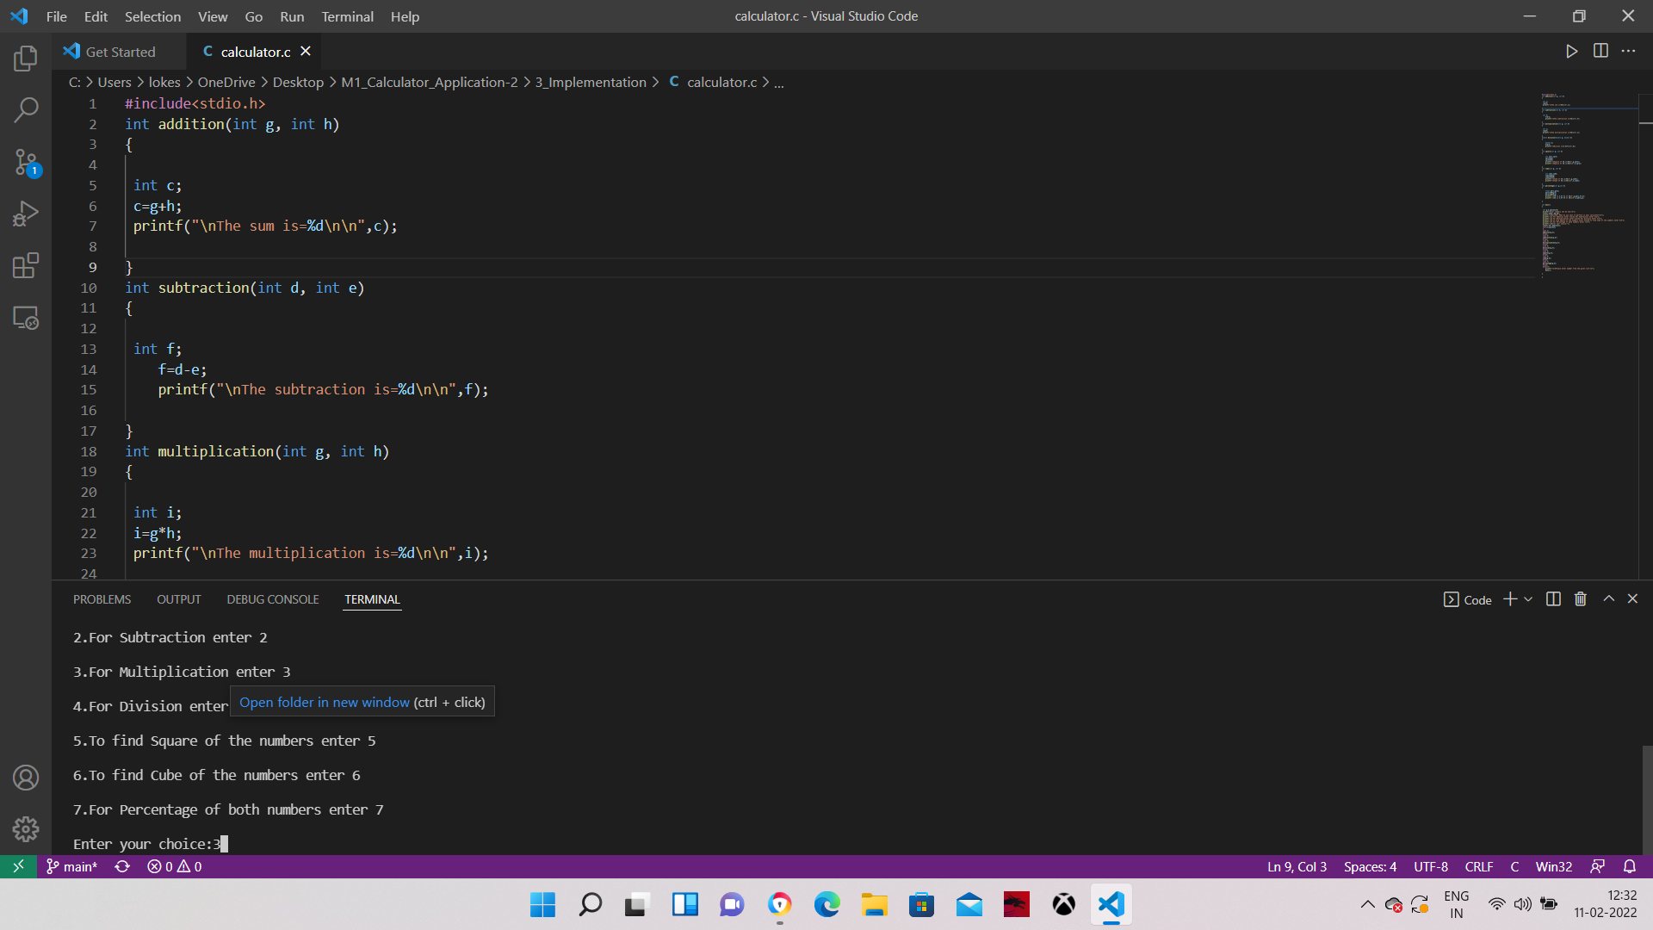

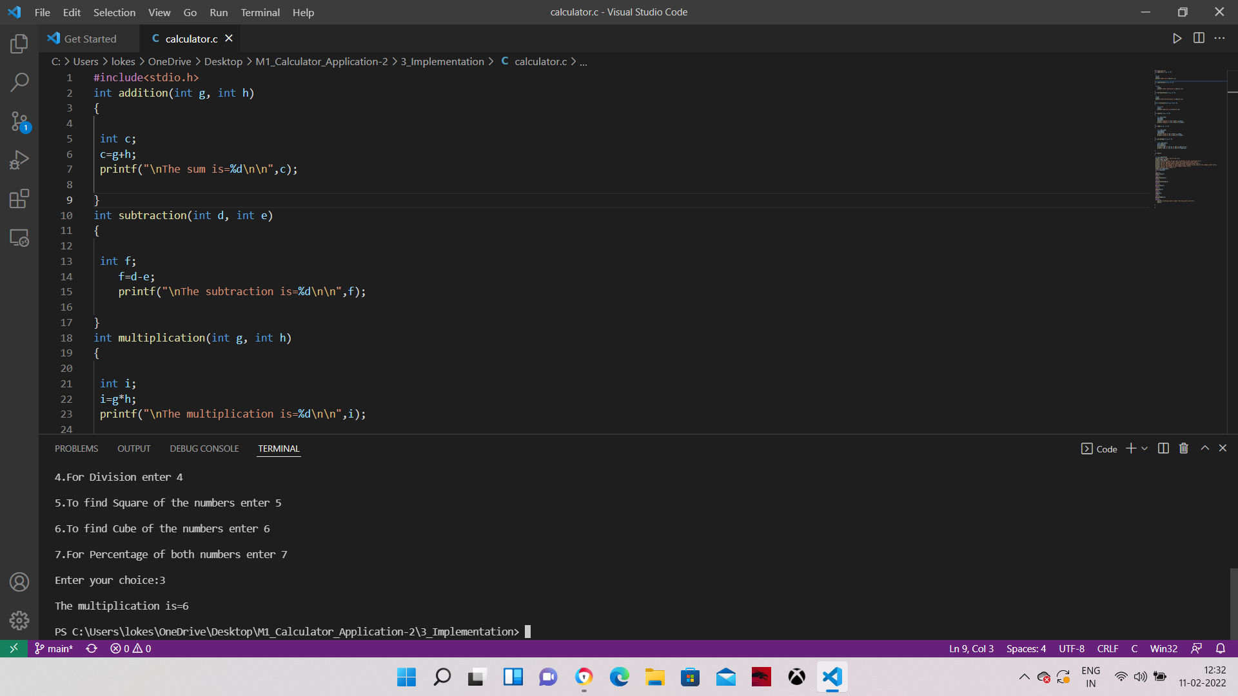

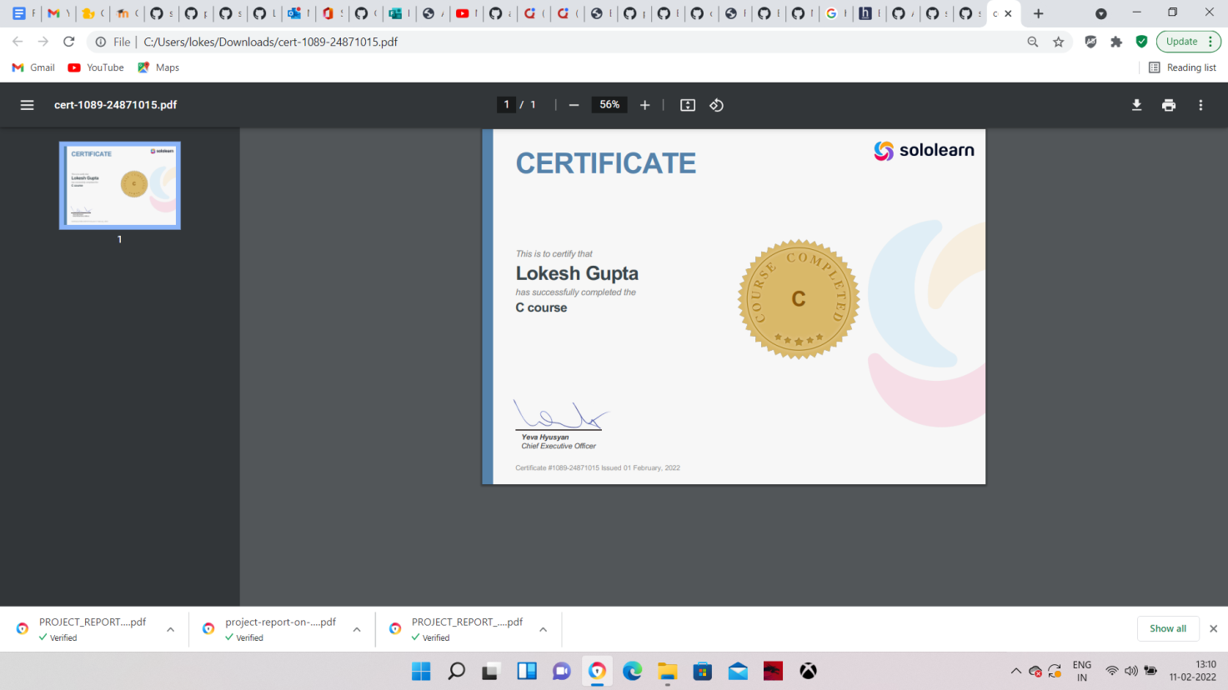

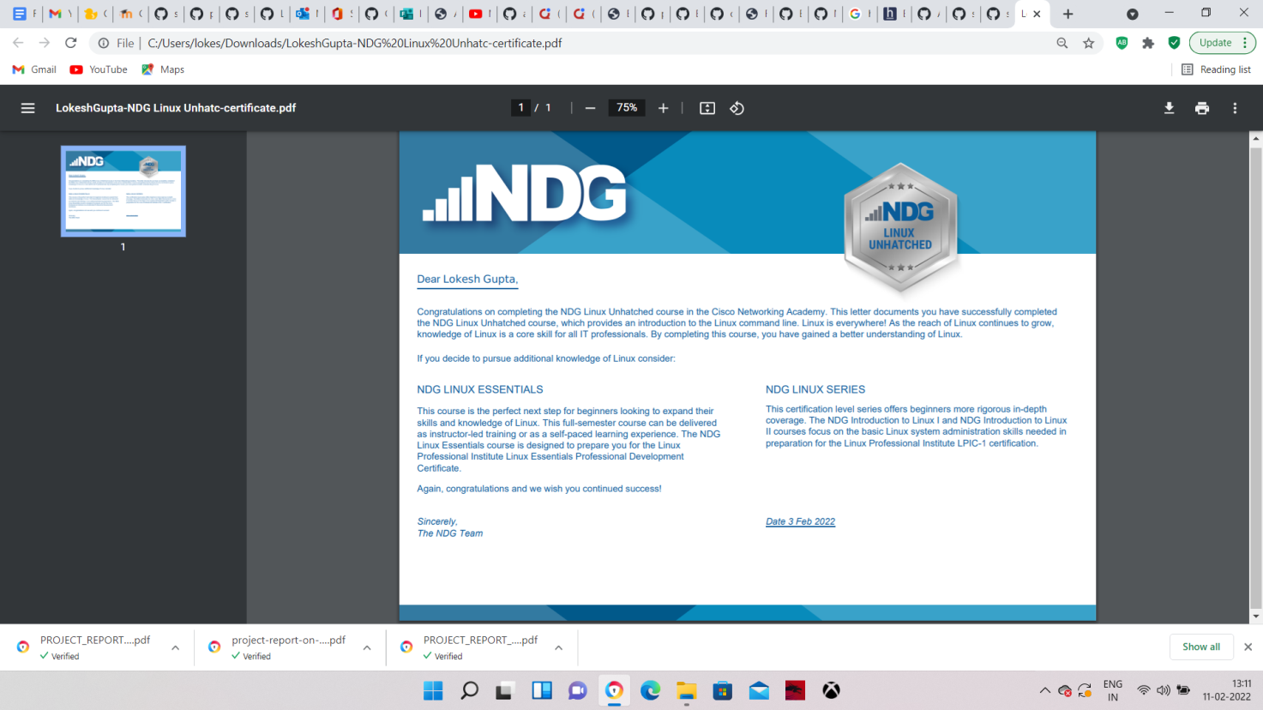

Description:

1:This project is about making a digital simple calculator .

2:This work is centered on the design and implementation of calculator for education organization.

3:To make a easier working tool capable of mathematical knowledge and solving sophisticated problems.

4:The Project is primarily focused on numbers and arithemetic operations.

5:It will help in calculating mathematical problems,and also easy to retrieval of project.

Research:

To make C program for the a simple alculator which can calculate Addition, Subtraction, Multiplication, Division, finding Square,Cube, and Percentage of the numbers.

It may be little bit tricky but here we will use the basic concepts of C programming as follows:

function call,

recursion,

if-else statement

switch-case

Cost and Features:

• The advantage of this project the the quickness in which the program works and no need to perform heavy calculation which will be taken care by the program

• A lot of time and money can be saved in this project as the result leads to quick installation and accurate results.

Defining MY System:

• The system will be getting some essential paramenters from the user and it will compute the values and with which it will be able to choose or design the product.

4W's and 1'H:

Who:

• Intended for people who want to calculate addition, subtraction, multiplication,division, square, cube and percentage of numbers.

What:

• It provides you with quick calculation arithmetic problems.

When:

• When students or anyone can use this calculator for education or teaching purpose.

Where:

• Users can use this application on their desktop or laptop terminal.

How:

• Thinking about how the computations involved in finding the calculations can be easily implemented programmatically.

SWOT ANALYSIS :

![SWOT Analysis for calculator](https://user-images.githubusercontent.com/63411785/153553140-4a2e1ce7-80ce-408d-811b-75b55c937174.jpg)

Requirements:

High level:

1:Program will do addition, subtraction, multiplication, division. (Implemented)

2:It will find also find square, cube, and percentage of numbers. (Implemented)

Low level :

1:Variables are used to store results ,take operations, and take numeric values. (Implemented)

2:Switch case is used to jump to operators selected by user. (Implemented)

3:Divide operations will not divide bh zero. (Implemented)

References:

1:Seek help from colleagues.

Improvement:

1:practised and improved the code.

[![Codacy Badge](https://app.codacy.com/project/badge/Grade/347195fe10ec4698bcae9ad0ffb402e1)](https://www.codacy.com/gh/lokesh23799/M1_Calculator_Application/dashboard?utm_source=github.com&amp;utm_medium=referral&amp;utm_content=lokesh23799/M1_Calculator_Application&amp;utm_campaign=Badge_Grade)

![Code grade](https://api.codiga.io/project/31069/score/svg)

![Code grade](https://api.codiga.io/project/31069/status/svg)

[![cppcheck](https://github.com/lokesh23799/M1_Calculator_Application/actions/workflows/c-cpp.yml/badge.svg)](https://github.com/lokesh23799/M1_Calculator_Application/actions/workflows/c-cpp.yml)

# M1_Application_Calculator

I have made a C program for the simpe Calculator which can calculate Addition, Subtraction, Multiplication, Division, finding Square,Cube, and Percentage of the numbers.

Some basics of C that is used in this calculator project are as follows:

function call,

recursion,

if-else statement

switch-case

Thanks LTTS for giving me the opportunity to make a project on my own using the concepts of C programming.

Folder Structure

Folder Description

1_Requirements : Documents detailing requirements and research

2_Design : Documents specifying design details

3_Implementation : All code and documentation

4_Test_plan : Documents with test plans and procedures

5_Report : Documents with Report about the project

6_Videos and Images : Documents with Videos about the working of the project

7_Others : Documents with Data Sheets